Git commands :

git branch –r

git checkout <master> (to change branch)

git pull ars main

**Commands**

* init: this initializes a new repository
* add: adds the changes from working tree to staging area
* status: shows the status of working tree and changes
* commit: this command commits the changes from staging area to local repository
* log: shows the commits done in local repo
* git add comes with 4 major options for adding changes
  + git add
  + git add . adding all the changes relative to current directory
  + git add -A add all the changes
  + git add -u add only modified files
* To unstage the popular option is git restore --staged
* To remove the changes from working tree
  + modified: git restore
  + untracked:
    - delete normally
    - git clean -fd .
* Create a local repository
* create an empty directory and execute git init  
  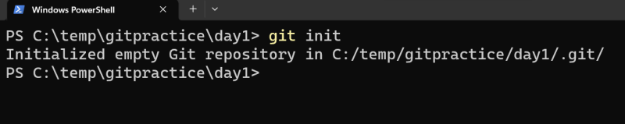
* Configure username and email id one time job  
  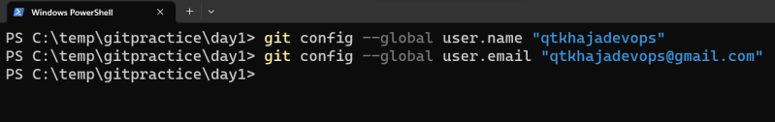
* For every commit git gives commit id with username, email, message and date time information  
  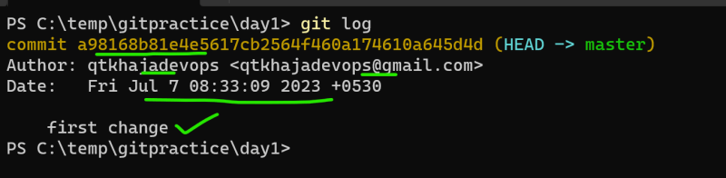
* git log --oneline (provides small commit id)

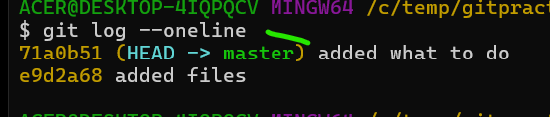

* git checkout –b <name of branch> (to create new branch)

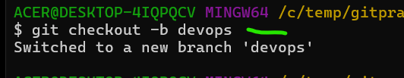

* To understand we will be using plumbing commands

git cat-file -t <commit-id>

git cat-file -p <commit-id>

* git rebase master
* git cherry-pick <commit id> (to add specific commit from one branch to another)

before doing this copy commit id and change to destination branch and execute commands

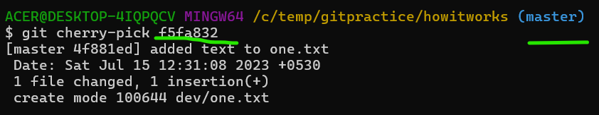

* to move back commit in a branch
* git show HEAD~<number to which you want to move back>

